BABALWA MPUNYUKA

Babalwa.mpunyuka@womentechsters.org

PRACTICAL ACTIVITY 3

**PART 1**

1. Listing the processes for the current shell using ps command.

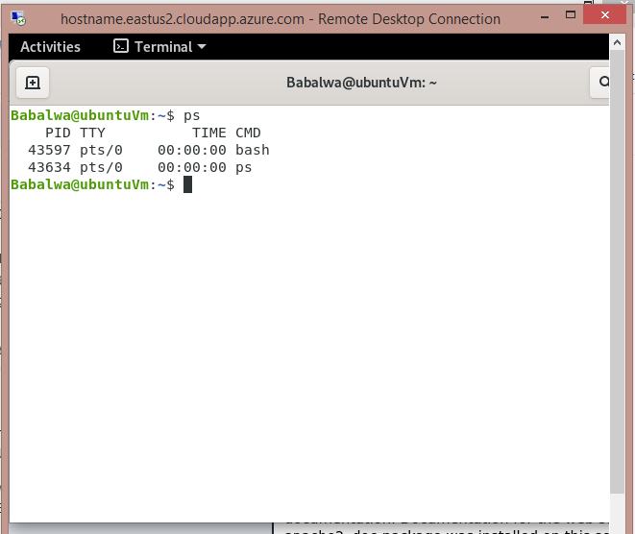

1. 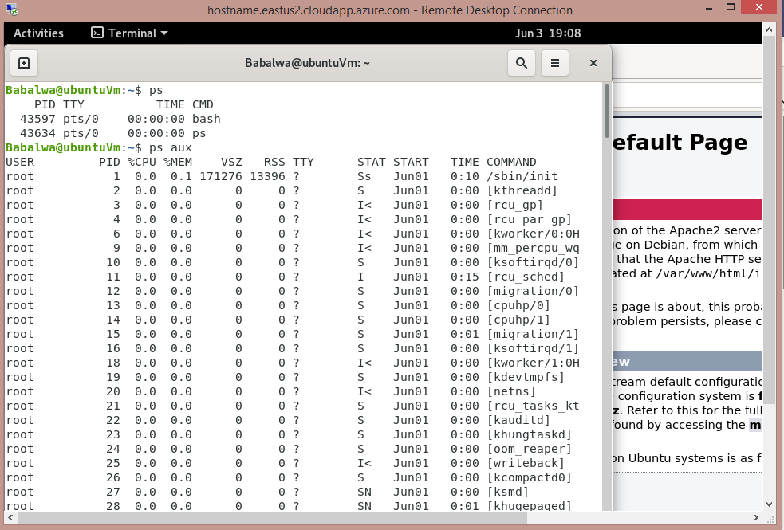Displaying information about processes using ps aux command.
2. Displaying the global priority of a process using ps -l command.

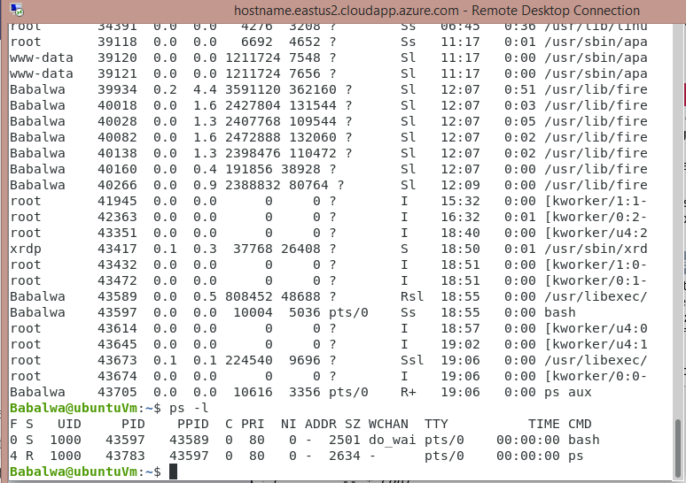

1. Change the priority of a process with default arguments.

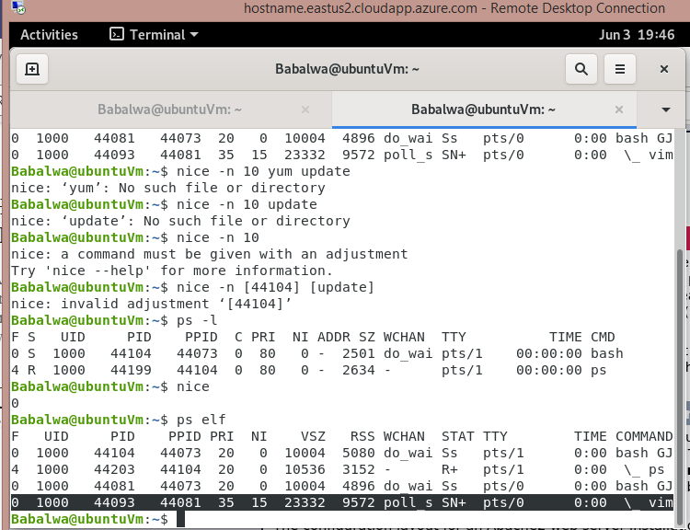

1. Displaying Virtual Memory Statistics using the vmstat command.

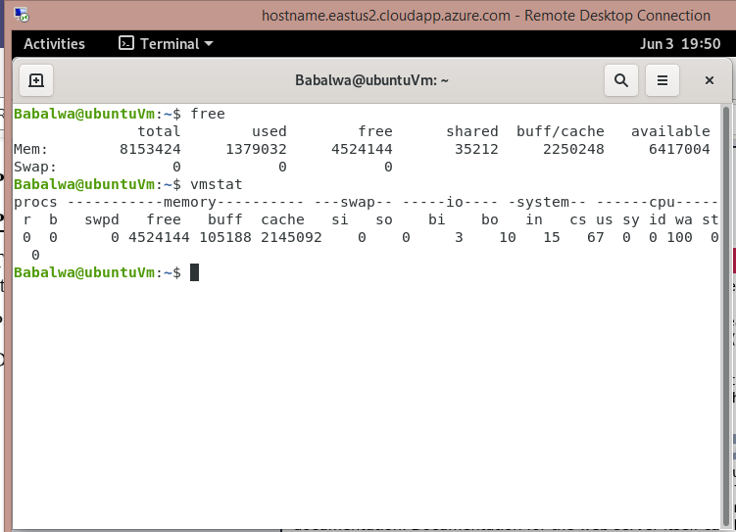

1. Displaying System Event Information.

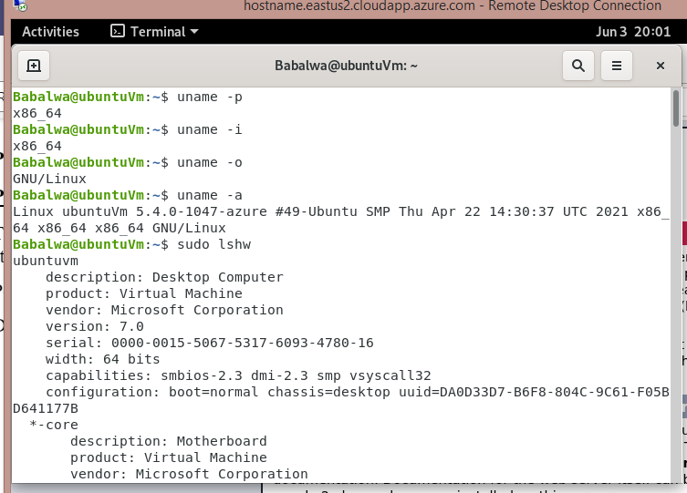

1. 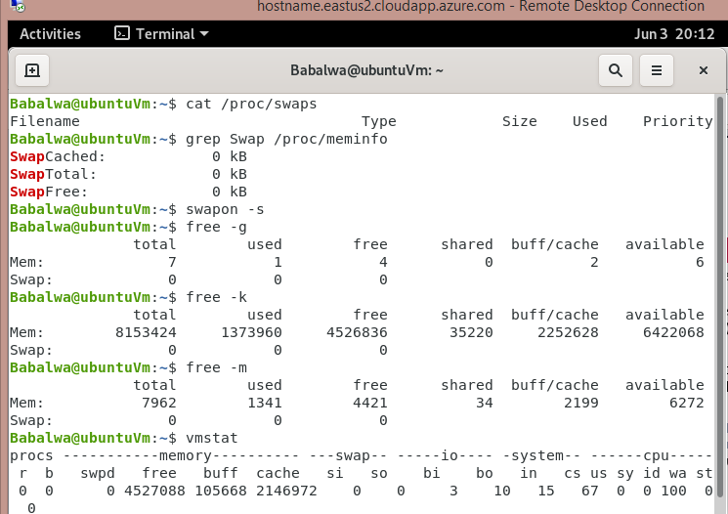Displaying Swapping Statistics.

1. Checking the File Access statistics using the ls –lh command.

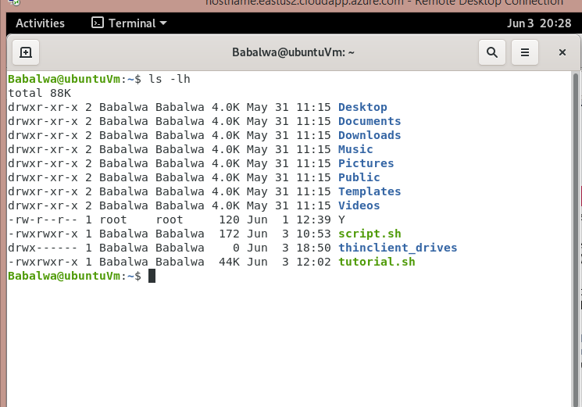

1. Checking for Buffer Activity statistics.

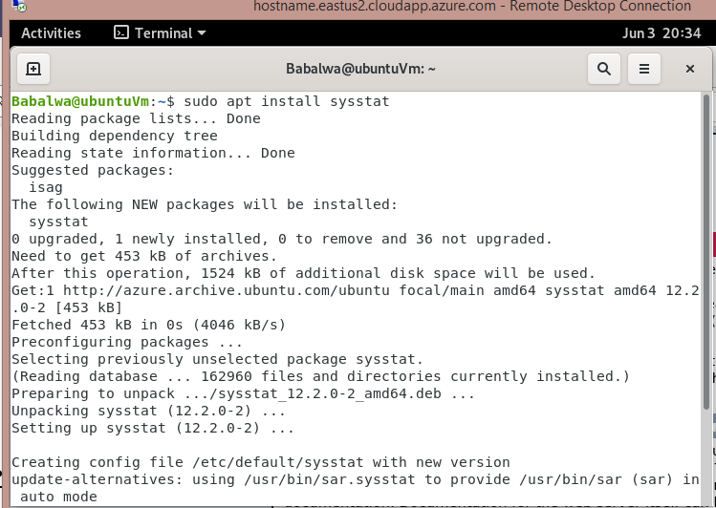

1. Checking for Disk Activity statistics.

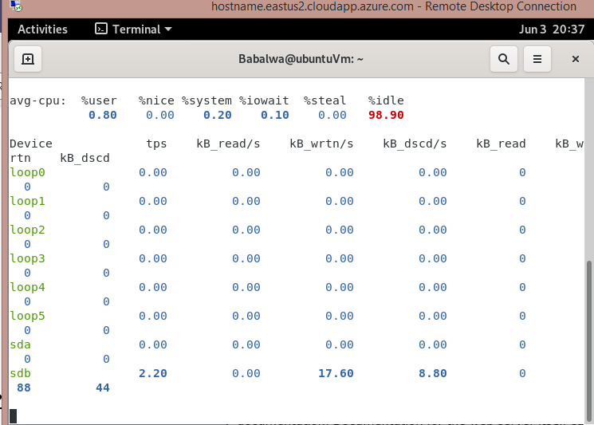

1. Checking the Inter process Communication statistics using ipcs -a

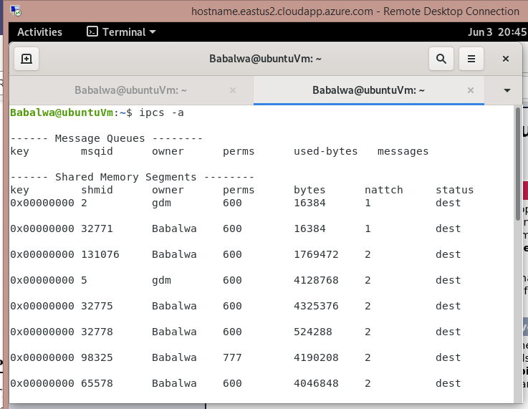

1. Checking the Unused Memory in the server.

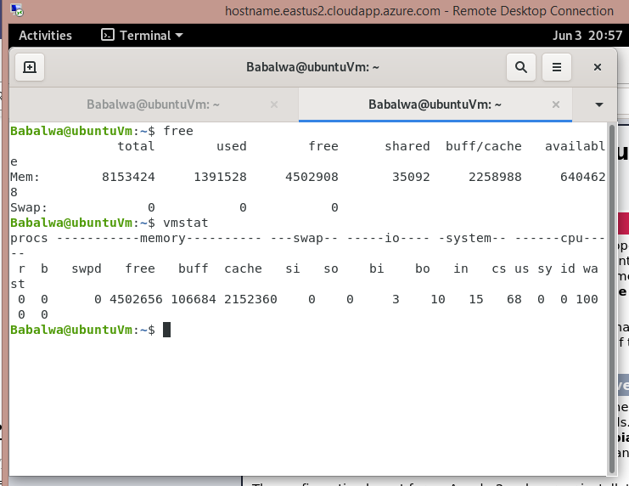

1. Checking Swap Activities.

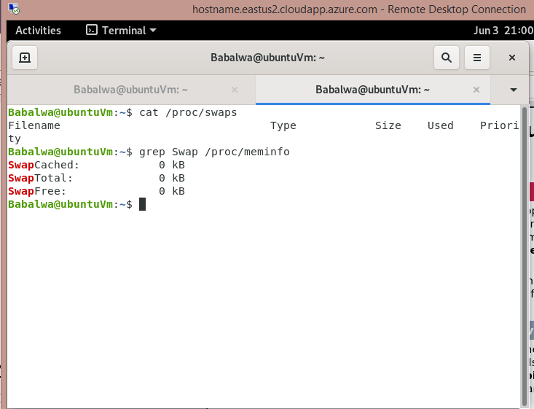

**PART 2**

1. 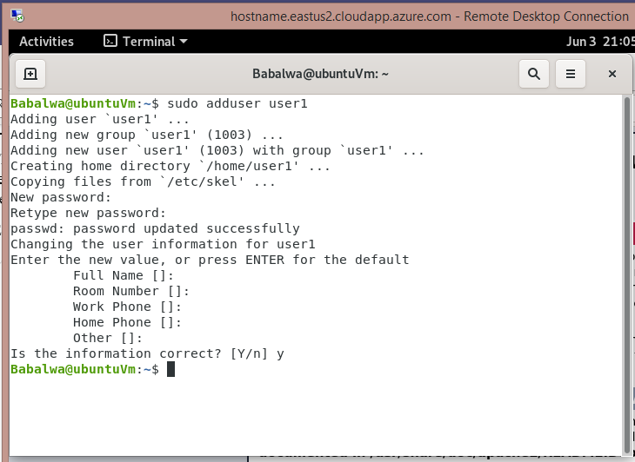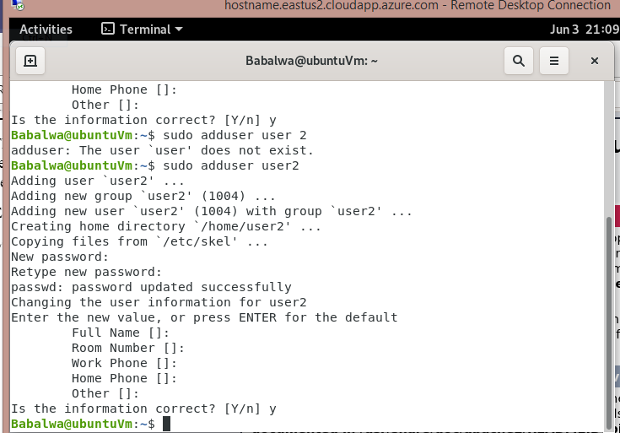Creating user accounts called user1 and another user2.
2. Ensuring that user1 and user2 are password protected.

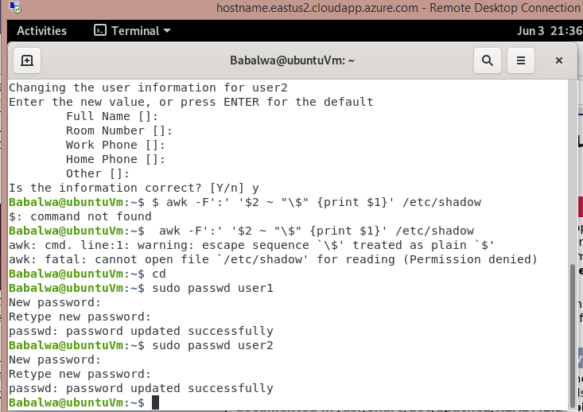

1. Logged out and logged in as user1.

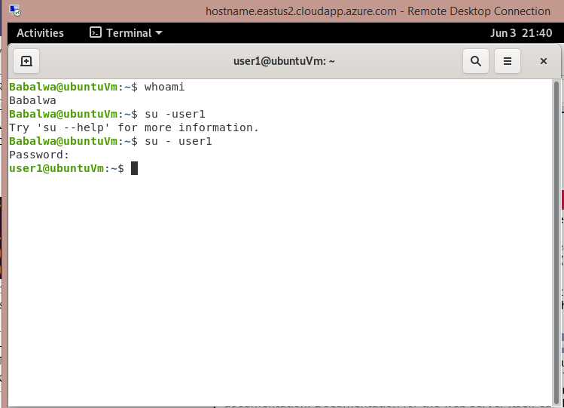

1. Creating a testdir.

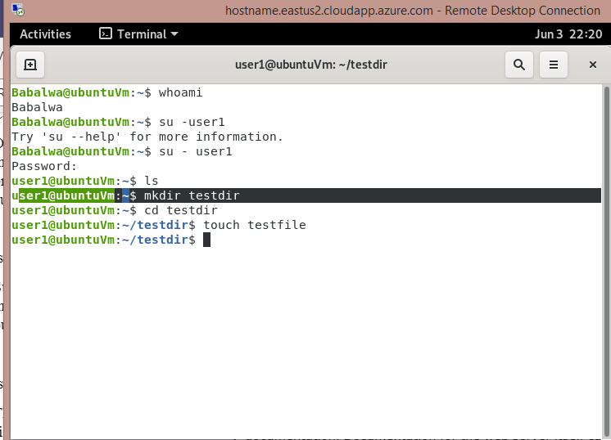

1. Creating a file testfile in testdir

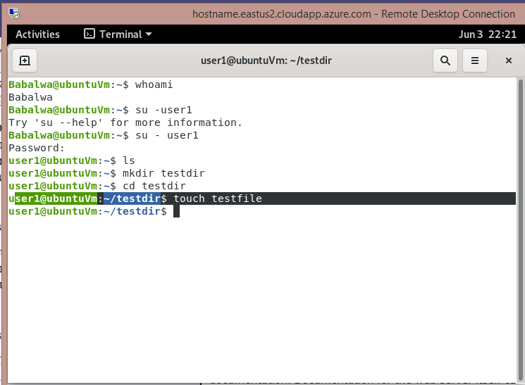

1. 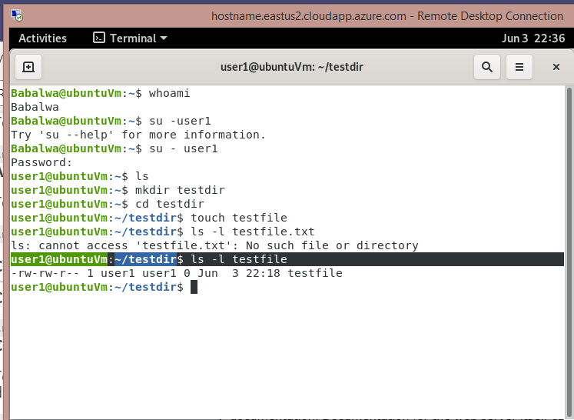Verifying the ownership and the group of the testfile.

1. Switching to Superuser account (root).

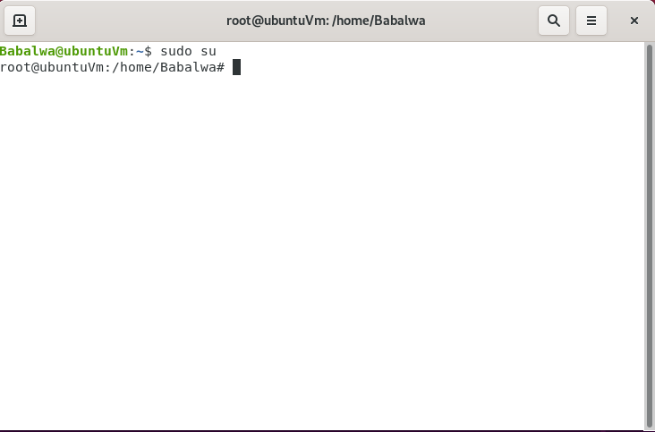

1. Creating a public directory dir1.

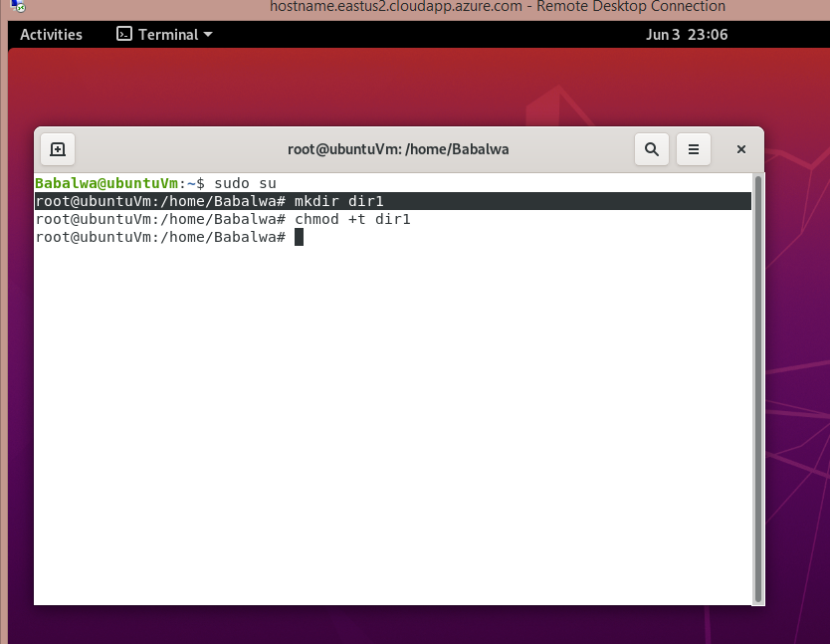

1. Set sticky bit (save text attribute) on dir1

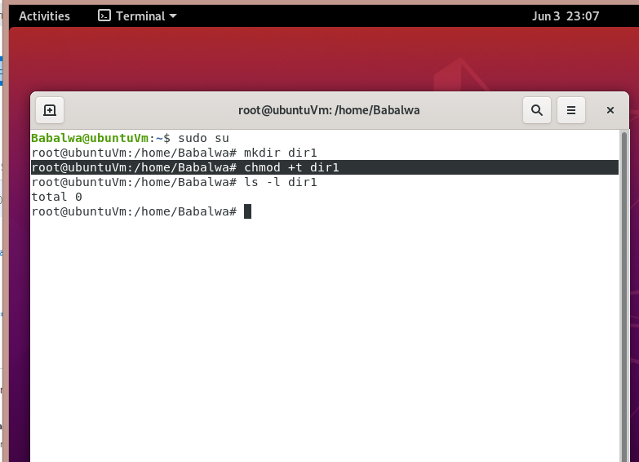

1. Logout and login as a normal user user1.

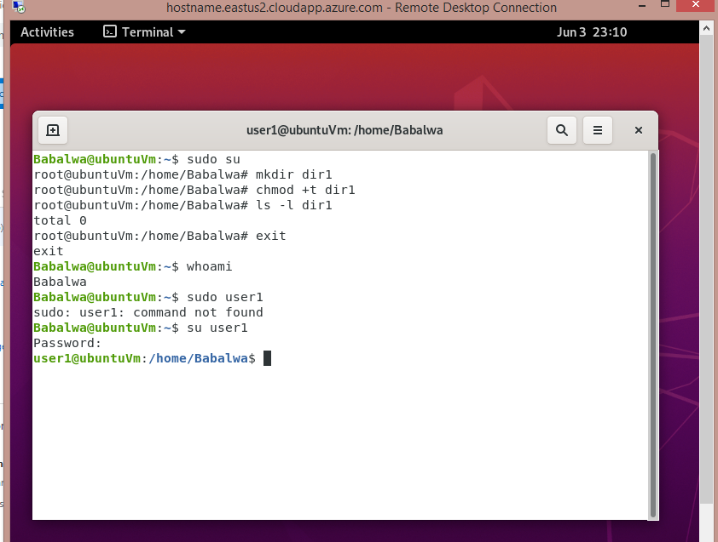

1. Creating a file userfile1 in dir1

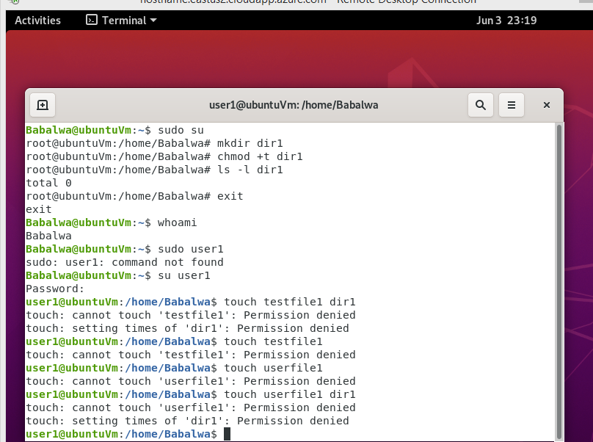

1. Logging in as a different user use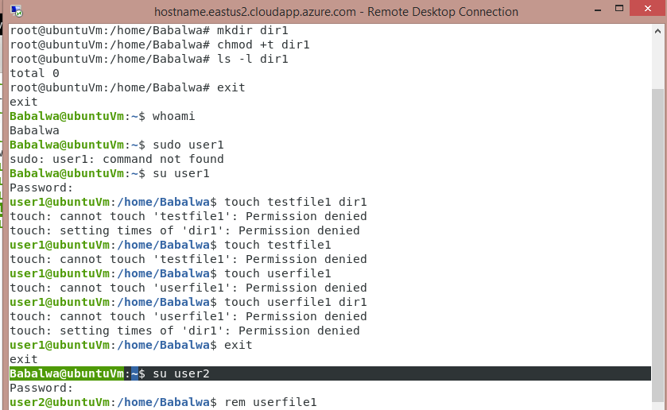r2

1. Try to edit or remove the file

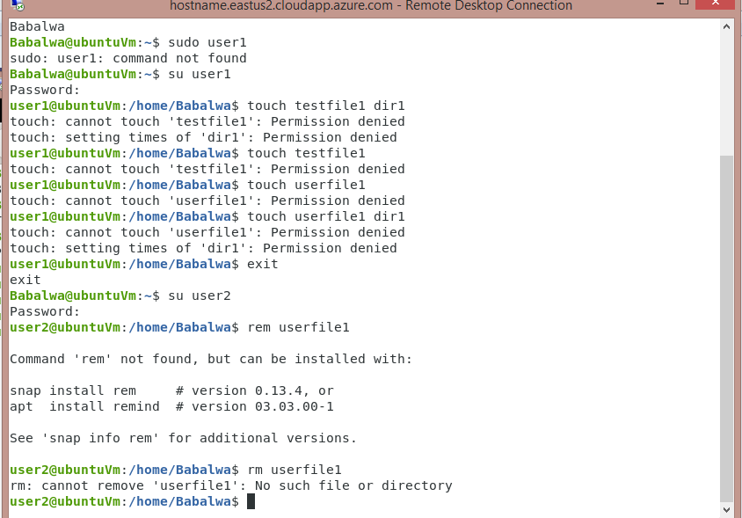

1. Temporarily disabling user logins

